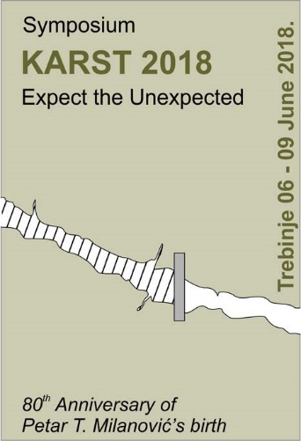
REGISTRATION FORM

Name:_____________________________________________________________________________

Surname:__________________________________________________________________________

Title:______________________________________________________________________________

Affiliation:________________________________________________________________________

Company:__________________________________________________________________________

Country:___________________________________________________________________________

Email:_____________________________________________________________________________

Title of paper:______________________________________________________________________

Accompanying person:
YES NO

Please send the form to: karst_2018_trebinje@karst.edu.rs

